 | American International University- Bangladesh (AIUB)  Faculty of Engineering
Course Name: | Engineering Ethics | Course Code: | EEE 3107
Semester: | Spring 2019-20 | Section: | D
Title: | A report on ethical guidelines (CO5)
Student Name: | Topu,jamiual amin | Student ID: | 16-32249-2
Student’s Department: | CSE | Submission Date: | 24-8-2020

Rubric:
Category | Proficient  [4] | Good  [3] | Acceptable  [2] | Unacceptable  [1] | Secured Marks
Resources  CA1 | Issue/problem to be considered critically and analysis has effectively involved using diverse resources. | Issue/problem to be considered and analysis has involved using diverse resources but not effectively. | Issue/problem to be considered has analyzed using some resources without any diversification. | Issue/problem to be considered has involved no or limited usage of resources.
Influence of context and assumptions  CA1 | Thoroughly (systematically and methodically) analyzes own and others’ assumptions and carefully evaluates the relevance of contexts when presenting a position. | Identifies own and others’ assumptions and several relevant contexts when presenting a position. | Questions some assumptions. Identifies several relevant contexts when presenting a position. May be more aware of others’ assumptions than one’s own (or vice versa). | Shows an emerging  awareness of present assumptions (sometimes labels assertions as assumptions). Begins to identify some contexts when presenting a position.
Student’s position  (perspective, thesis/  hypothesis)  CA3 | Specific position (perspective, hypothesis) is imaginative, considering the complexities of an issue. Limits of position (perspective, hypothesis) are acknowledged. Others’ points of view and assumptions are synthesized within position (perspective, hypothesis). | Specific position (perspective, thesis/hypothesis) considers the complexities of an issue. Others’ points of view and assumptions are acknowledged within position (perspective, hypothesis). | Specific position (perspective, hypothesis) acknowledges different sides of an issue. | Specific position (perspective, hypothesis) is stated, but is simplistic and obvious.
Innovative Thinking  or uniqueness (of idea, claim, question etc.)  CA3 | Extends a novel or unique idea, question, format, or product to create new knowledge or knowledge that crosses boundaries. | Creates a novel or unique idea, question, format, or product. | Experiments with creating a novel or unique idea, question, format, or product. | Reformulates a collection of available ideas.
Proper Documentation | Documentation and related outcomes are logical and reflect student’s informed evaluation and ability to place evidence. | Documentation and related outcomes are logically tied to a some of the information. | Documentation is logically tied to information (because information is chosen to fit the desired conclusion) but some related outcomes are not clear. | Documentation is inconsistently tied to some of the information discussed; related outcomes (consequences and implications) are oversimplified.
Comments: |  |  | Total Marks  (Out of 20):

A report on ethical guidelines:

Suppose, you are going to set up a startup company in Bangladesh. You need to mention the type of the company and to give a brief idea about it's organizational structure. Write the code of ethics for your startup. This code should provide guidelines for ethical and professional conduct and should comply with the code of ethics of IEB.

Hints: You may include but not be limited to the following issues to write code of ethics:
Ethical Work Environment.
Health and Safety standards.
Professional Engineering.
Economic, Social and Environment Factors.

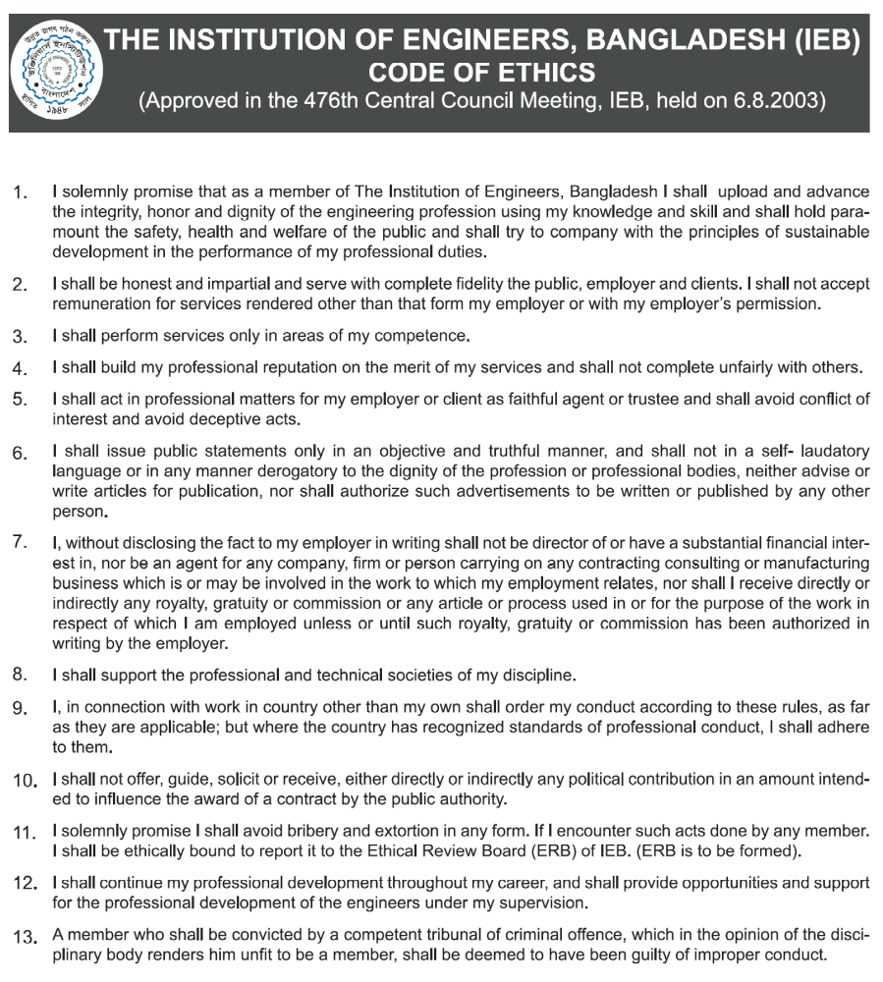

Answer:

The code of our company conduct shows as a guideline for our daily business interactions which is showing our standard for perfect behavior and our corporate values. this clearly conveys to each of us that in business the behaviour are all that matters.The code of conduct of our company applies to all the staff of our company, including directors,officers and all employees of the Company.

We have commitment to the society that conduct the best ethical standards.following the code is easily to confirm by using good judgment and seeking good follow up when problem arise. All of us is responsible for our decision-making and for our comfort with the code.

The code of ethics of our company are following bellow:

:
The focus of our company to benefit the country. All we do has to be with the laws of the land.In the course of our business activities, we have to respect the culture and traditions of our country and region in which it operates.

:
We shall be committed to the governance systems of the country in which it operates. We shall not support any specific political party or candidate for political office and shall not offer or give any company funds as donations to any political party, candidate or campaign.

- We will treat each other with respect, recognition and consideration same gender equality and having faith to others.
- We will communicate and consult with each other openly and honestly to full fill our duties faithfully.
- We are committed to consider members of our company as a key source of strength and support of our company.So we will do everything possible to give the facilitate suitable participation to every members.
- We will keep all the members informed of our work, and give effort to respond to all requests and questions from all the members fairly.

Everyone’s judgment is one of your most valuable assets. all should avoid any activity, interest or association that conflicts with or appears to compromise our exercise of independent judgment in the Company’s best interests. Conflicts can arise in many situations. It is impossible to cover them all here. When you have in doubt, consult your manager or the Chairman/Managing Director before taking any action.

:
- We will treat information obtained in the service of company with confidentiality and will not use any such information or materials to further a private interest.We are committed to remain faithful to the commitment after our separation from the company.
- We will be as open as possible about all decisions and actions we take, taking into account the above mentioned needs for confidentiality.

We respect the personal privacy rights of our employees, consumers, customers, suppliers and other individuals with who has a business relationship. As part of their employment with the company, employees may provide certain personal information to the company, such as home and e-mail addresses, family information for benefits purposes, and other personal information. We use such information only for the reasons it was supplied to us but never try to create problem to them by using there information.

Company assets and liabilities should be properly recorded and appropriately valued. Company assets, facilities or services must be used only for lawful and authorized purposes. The theft of money, property or services is strictly prohibited.

Our target will be honest dealing with customers and suppliers.We view our suppliers as partners and expect them to make a reasonable profit.We extend no personal favors to customers on prices, promotional allowances, marketing assistance or the like; we treat all customers on the same business basis.
.

The company will provide a safe, healthy, clean and ergonomic working environment for its people.In the process of production and sale of its products and services, shall strive for economic, social and environmental sustainability.

- We will avoid giving or accepting gifts, favours and gratitudes in connection with official duties.
ii. We will not accept directly or indirectly any discount, gift, entertainment, or favours that may influence or perceived to influence the exercise of our function or the performance of our duties or our judgment.
iii. All gifts will be reported to the supervising officer and recorded on a document that is available to all the staff.

THE CODE APPLIES TO ALL PEOPLE AND COMPANY ACTIVITIES:
The Code is applicable to everyone who works for the company including officers, and also applies to the Company’s directors and agents in accordance with applicable law.

However, we have to remember this will not automatically follow.we have to follow the rules and ethics of the company by our own.

To complete this report I have used many recourse such as IEEE,ACM,NSPE etc.

